Patient file number: _________
NEW PATIENT INFORMATION
Mr / Ms / Miss / Mrs / Dr

Surname: ____________________________________________________ Given name(s): _____________________________________ ______________

Address: __________________________________________________ Suburb: ____________________________________ Postcode: ______________

Phone (Home): _________________________________ Work:_____________________________ Mobile: ____________________________________

Date of birth: _______/_______/_______ Email: _______________________________________________________ □ Male □ Female

Occupation: __________________________________________________ Employer: _______________________________________________

Spouses/Next of kin: _____________________________________ Contact number: ______________________________________________

Who recommended you to this clinic? _________________________________________________________________________________________

IF YOU HAVE RECIEVED CHIROPRACTIC CARE BEFORE, PLEASE COMPLETE
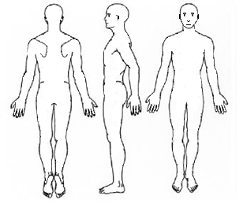
THE FOLLOWING

Name of chiropractor: ___________________________________________________

Reason for treatments: __________________________________________________

Approx. how many adjustments were given: __________________________

When was the last adjustment: _________________________________________

Check off any of the following symptoms you have experienced in the past 6 months:
Low back pain |  | Tension across top of shoulders |  | Nervous
Pain between shoulder blades |  | Numbing/Tingling in arms or hands |  | Difficulty sleeping
Neck pain |  | Numbing/Tingling in legs or feet |  | Allergies
Tension/ Migraine headaches |  | Dizziness |  | Digestive problems
Tired, fatigued |  | Ringing in ears |  | Weight trouble

Which of the above is worse? __________________________________ How long have you had it? ______________________

Any previous treatment for the issue? (If yes, describe) ________________________________________________________________

Does this cause you to be (please tick):

Irritable |  | Interrupt sleep |  | Restrict daily activities

Does this affect your work:
Poor attitude |  | Decreased productivity |  | Exhausted at end of day

Does this affect your life:
Restrict household duties |  | Hinders ability to exercise |  | Hinders ability to participate in other activities

Where is your most serious problem? ___________________________________________

How long have you had this problem? ______________________________________________

How did this occur/start? ___________________________________________________________

Have you had the problem before? If yes, when? __________________________________

Did you have any treatment? What was the result? ________________________________

Is the pain: constant / periodic? (Circle) Have you taken any pain relief? _________________________________________________

What type of pain is it? ______________________________ Since the problem started is it getting: better / the same / worse

What aggravates the pain? ____________________________________ What relieves the pain? _____________________________________
Does your current health concerns prevent any activities? _________________________________________________________________

Circle the level of discomfort on the scale: (no pain) 0 1 2 3 4 5 6 7 8 9 10 (worst pain)
_______________________________________________________________________________________________________________________________________
Where is your 2nd most serious problem? ______________________________________

How long have you had this problem? _______________________________________________

How did this occur/start? ____________________________________________________________

Have you had the problem before? If yes, when? ___________________________________

Did you have any treatment? What was the result? _________________________________

Is the pain: constant / periodic? (Circle) Have you taken any pain relief? ________________________________________________

What type of pain is it? _____________________________ Since the problem started is it getting: better / the same / worse

What aggravates the pain? _____________________________________ What relieves the pain? __________________________________
Does your current health concerns prevent any activities? ________________________________________________________________

Circle the level of discomfort on the scale: (no pain) 0 1 2 3 4 5 6 7 8 9 10 (worst pain)
__________________________________________________________________________________________________________________

MEDICATION/TRAUMA/ACCIDENTS

Please list any medications you are currently taking and condition which you are taking them:

__________________________________________________________________________________________________________________________________

__________________________________________________________________________________________________________________________________

Please list any operations or surgeries in your lifetime (List type of surgery and age at the time):

__________________________________________________________________________________________________________________________________

__________________________________________________________________________________________________________________________________

Please list any trauma/accidents in your lifetime (car accident/concussion/broken bones and age at time):

_________________________________________________________________________________________________________________________________

_________________________________________________________________________________________________________________________________
INFORMED CONSENT TO CHIROPRACTIC CARE

- We invite you to discuss with us any questions regarding our services. The best services are based on a friendly, mutual understanding
between provider and patient.
- Our policy requires payment in full or all services rendered at the time of visit. Unless other arrangements have been made with the
business manager (in writing) if account is not paid. You will be responsible for all fees occurred in collecting your account.

Chiropractic care is recognised as being an effective and safe method of care for many conditions. However, you must recognise that there are risks associated with all health procedures.

It is a legal requirement of any practitioner who performs spinal manipulation – including chiropractors, physiotherapists and GPs – to inform
you of all the potential risks associated with these procedures.

In extremely rare circumstances, some treatments of the neck may damage a blood vessel. And give rise to a stroke or stroke-like symptoms (approx 1 in 5.85 million)1, fractures or disk injuries. Whilst this has never occurred in this clinic, we are still required to warn you.

Other very slight risks include strain/injury to a ligament or disk in the neck (less than 1 in 139,000) or the low back (less than 1 in 62,000)2, joint soreness, dizziness, nausea, headaches, or aggravation of your underlying condition.

ACKNOWLEDGEMENT
I acknowledge that I do not expect the Doctor of Chiropractic to be able to anticipate all risks and complications associated with the proposed chiropractic care.

We do not offer advice regarding treatment prescribed by others.

The emphasis in the office is correction/improvement of the spinal posture and function not just solely symptomatic relief.

I acknowledge that in this office we only diagnose and treat vertebral subluxation (spinal misalignment) we do not treat any medical conditions. However should abnormal findings occur in your exam you will be informed and referred to a general practitioner.

I acknowledge that I am aware of and understand the potential risks associated with that care.

I will have had the opportunity to discuss with the Doctor of Chiropractic any concerns regarding my consulation plus exam, and have been given sufficient time to consider giving my consent to proceed.

I appreciate that results cannot be guaranteed.

I hereby give my consent to the performance of chiropractic examination and treatment by the chiropractic practitioner Dr. Jens Sorensen or any other chiropractor working in this clinic.

I intend for this consent to apply to all present and future treatments, but understand that I may withdraw consent at any time.

I understand the above information and guarantee this form was completed correctly to the best of my knowledge and understand it is my responsibility to inform this office of any changes to the information I have provided (in writing).

Signature: ___________________________________

Date: ______/______/______

□ Adult patient □ Parent or Guardian □Spouse
- Neck manipulations. Haldeman, et aL Spine vol 24-8, 1999
- Dvorak Study in Principals and Practice of Chiropractic, Haldeman, 2nd Edition.

PERMISSION TO X-RAY
I grant permission for x-rays to be taken if it will contribute to the appropriate management of my condition.
I further certify that, to the best of my knowledge, I am not pregnant (females only).

Patient signature ____________________ Date _____/_____/_____

 | FFD | KV | MAS
Lat CX | 150-170(160)
Lat TH | 110-140 (120)
Lat LS | 90-120 (100)
AD LP | 120-150 (140)
AP CX/TH | 130-170 (140)

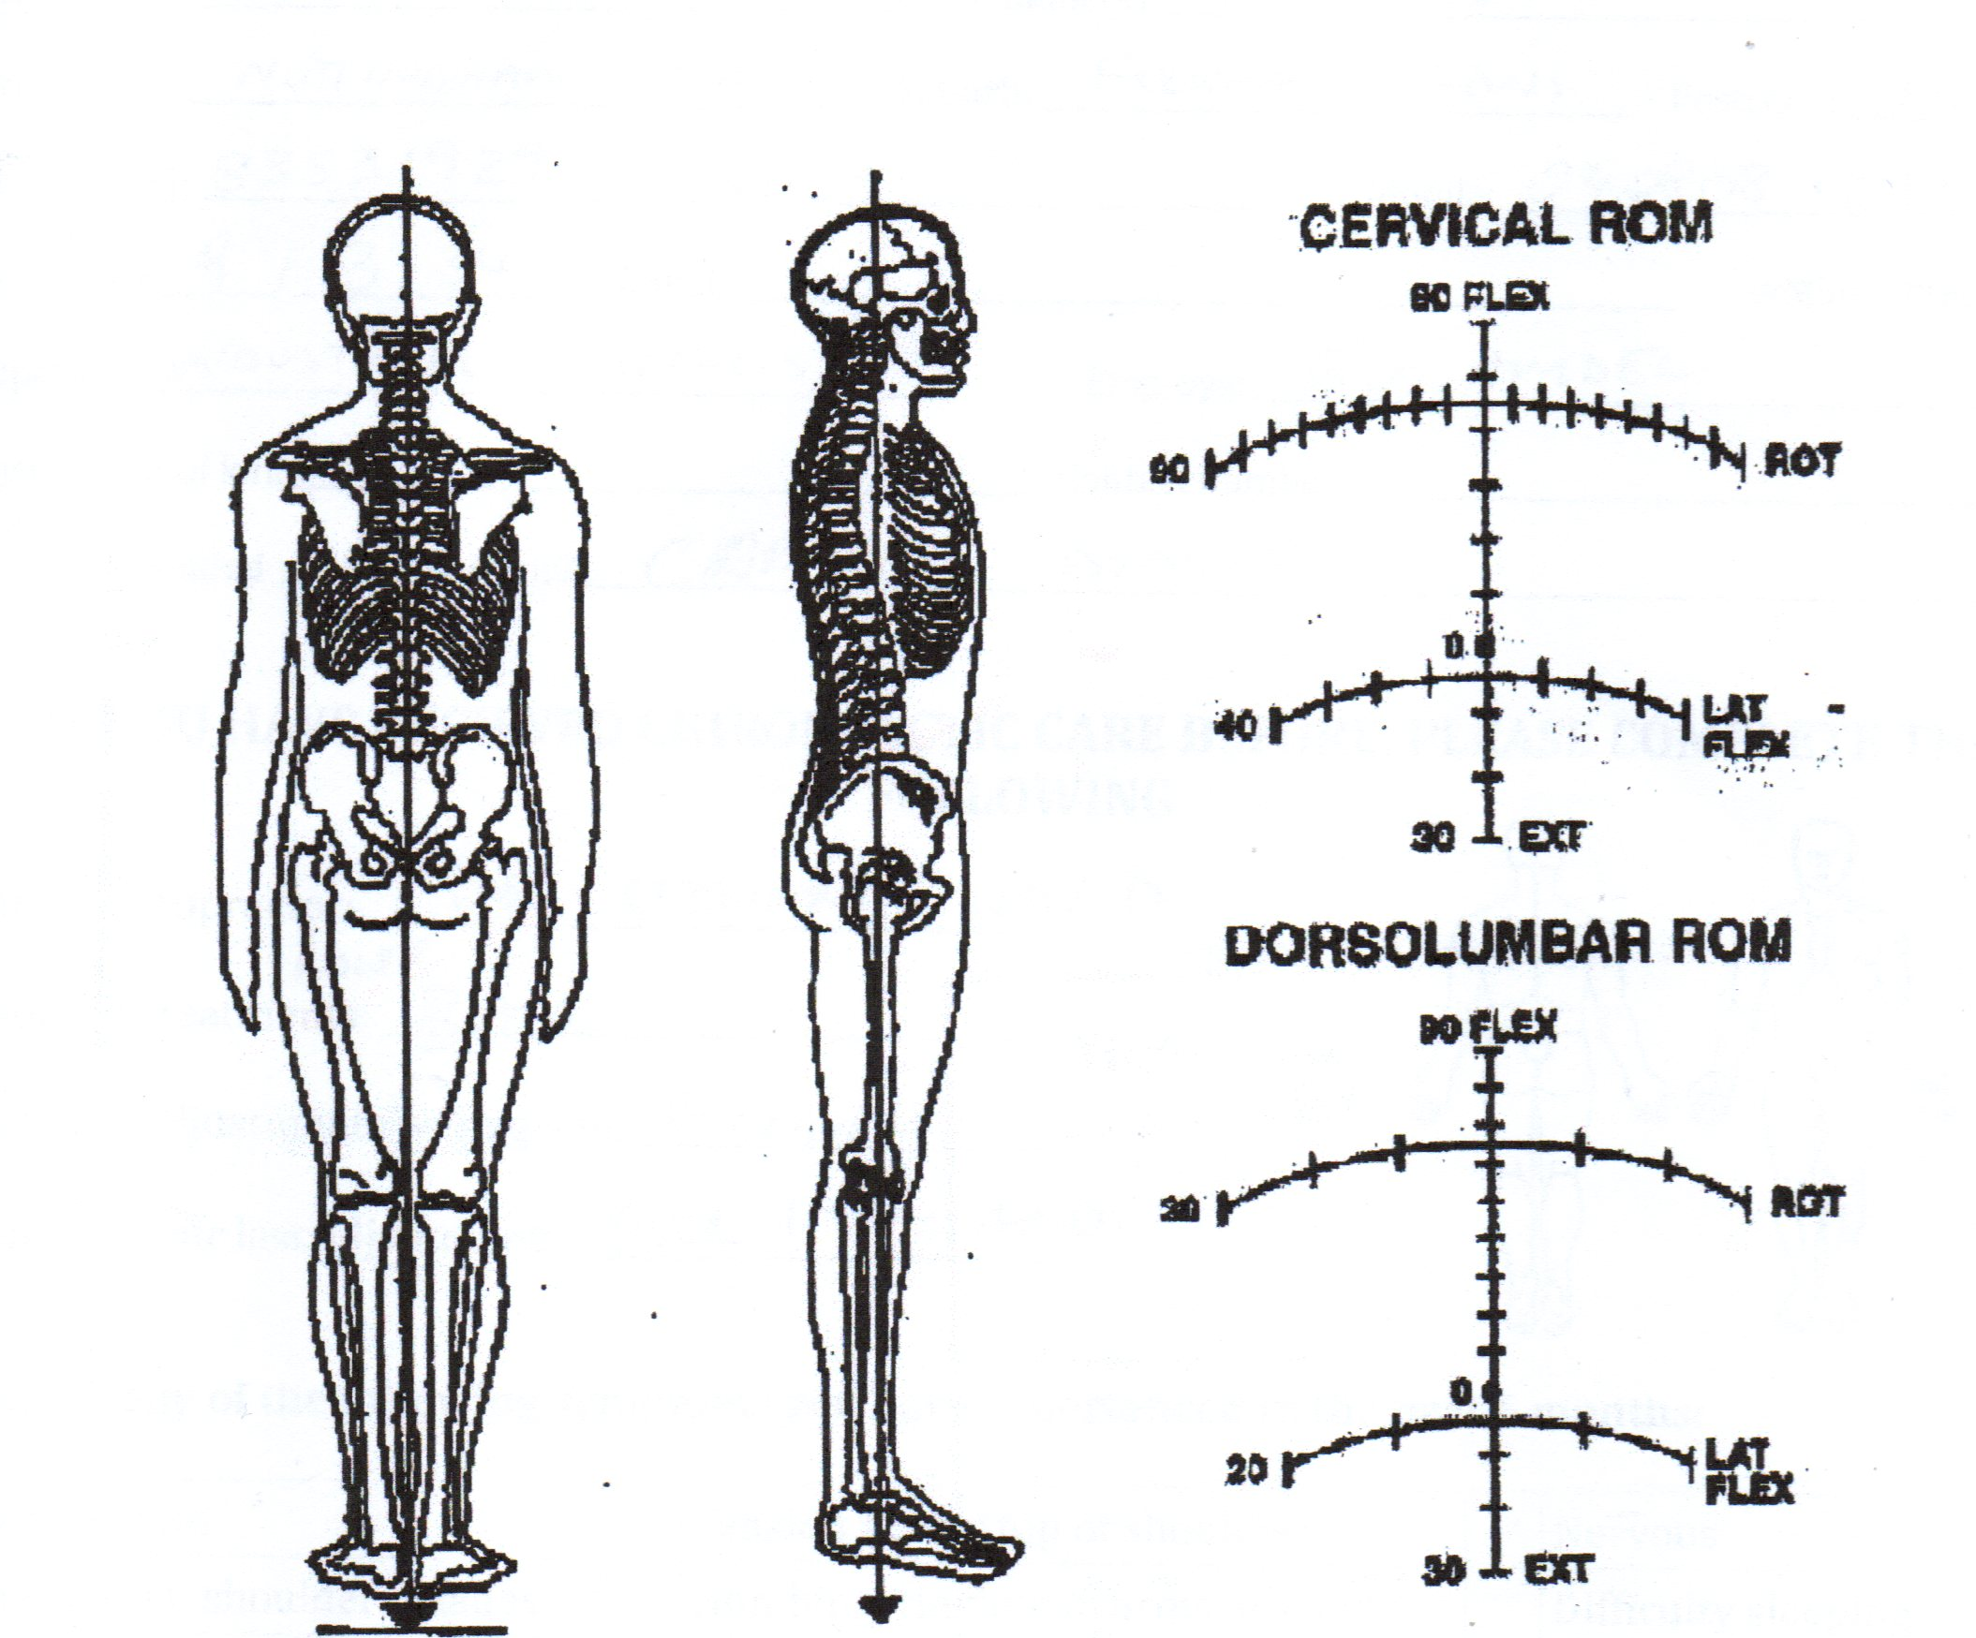
EXAM CHART

Notes:

